**NOTE:** One or more NGO’s can work on a single project and Ome or More donors can fund a single project VIA one or more NGO’s.

**Q1)** Identify all NGOs actively working in the Health, Education, and Gender group, together with the number of projects and total amount of funds received by each NGO.

**SQL Code with sample output:**

**SELECT**

n.ngo_name as ngo_name,count(distinct p.id) as no_of_projects,format(sum(f.amount+f.monetary_value), 2) as funds_received

**FROM**

ngo n,

funds f,

project p,

project_activity pa,

activities a,

class c

**WHERE**

n.id = f.ngo_id

and f.pro_id = p.id

and p.id = pa.pro_id

and pa.act_id = a.id

and a.class_id = c.id

and p.end_date is null

and c.name in **('HEALTH','EDUCATION','GENDER')**

**group by ngo_name**

order by no_of_projects desc;

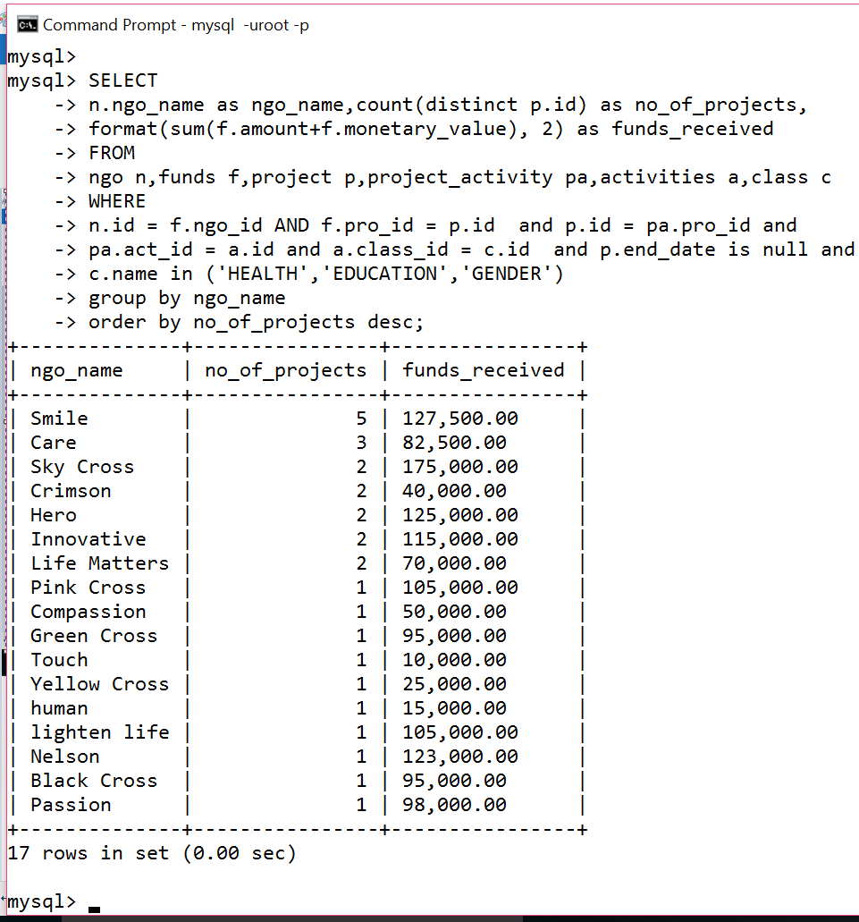

**RA Expression:**

**Π**ngo_name, numberOFprojects, FUNDSreceived

{

**γ**ngo_name, count(distinct R4.pro_id) → numberOFprojects, SUM(F.amount+F.monetary_value) → FUNDSreceived

{

**σ**NGO.id=F.ngo_id

[

NGO **⨝** [

**σ**F.pro_id=R3.pro_id(F**⨝**(**σ**R1.act_id=R2.id(**ρ**(R3,

(**σ**P.id=PA.pro_id AND P.end_date<>NULL(**ρ**(R1,(P**⨝**PA))))**⨝**

(**σ**A.class_id=C.id AND C.name='Health' OR 'Education' OR

'Gender'(**ρ**(R2,(A**⨝**C))))))))

]

]

}

}

**RA Expression Trees:**

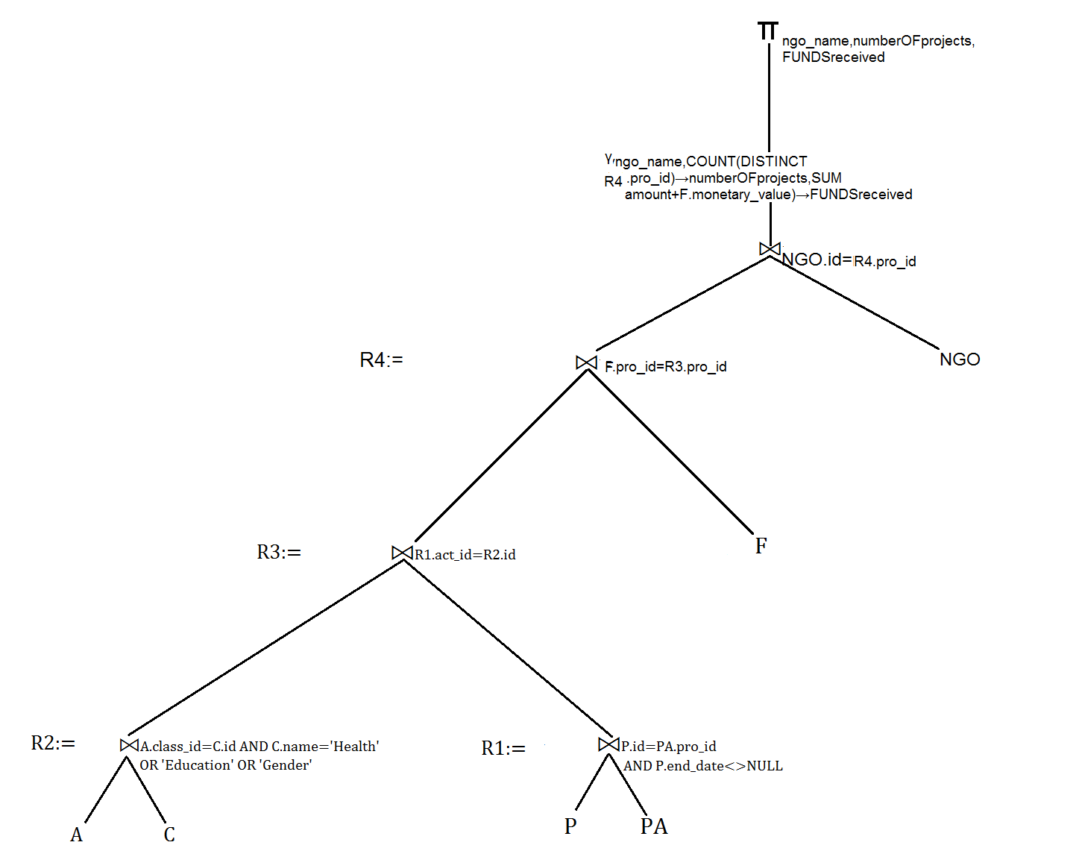

**Q2)** Repeat the query in [1] for the Youth Development, Child Protection, and Nutrition group.

**SQL Code with sample output:**

**SELECT**

n.ngo_name as ngo_name,count(distinct p.id) as no_of_projects,format(sum(f.amount+f.monetary_value), 2) as funds_received

**FROM**

ngo n,

funds f,

project p,

project_activity pa,

activities a,

class c

**WHERE**

n.id = f.ngo_id

and f.pro_id = p.id

and p.id = pa.pro_id

and pa.act_id = a.id

and a.class_id = c.id

and p.end_date is null

and c.name in **('YOUTH DEVELOPMENT','CHILD PROTECTION','NUTRITION')**

**group by** ngo_name

order by no_of_projects desc;

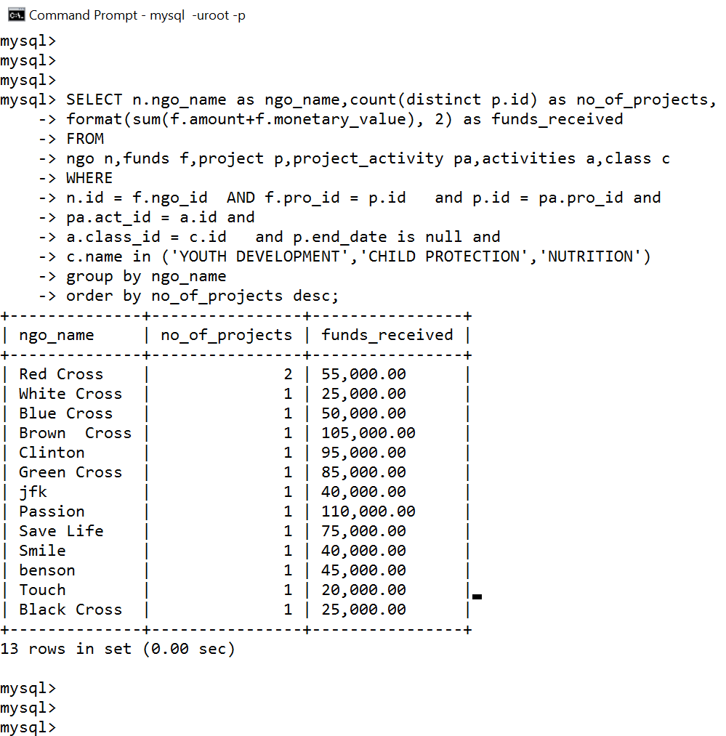

**RA Expression:**

Πngo_name, numberOFprojects, fundsReceived

{

γngo_name, count(distinct R4.pro_id) → numberOFprojects, SUM(F.amount+F.monetary_value) → fundsReceived

{

σNGO.id=F.ngo_id

[

NGO ⨝ [

σF.pro_id=R3.pro_id(F⨝(σR1.act_id=R2.id(ρ(R3,

(σP.id=PA.pro_id AND P.end_date<>NULL(ρ(R1,(P⨝PA))))⨝

(σA.class_id=C.id AND C.name='Youth Development'

OR 'Child Protection' OR ' Nutrition'(ρ(R2,(A⨝C))))))))

]

]

}

}

**RA Expression Trees:**

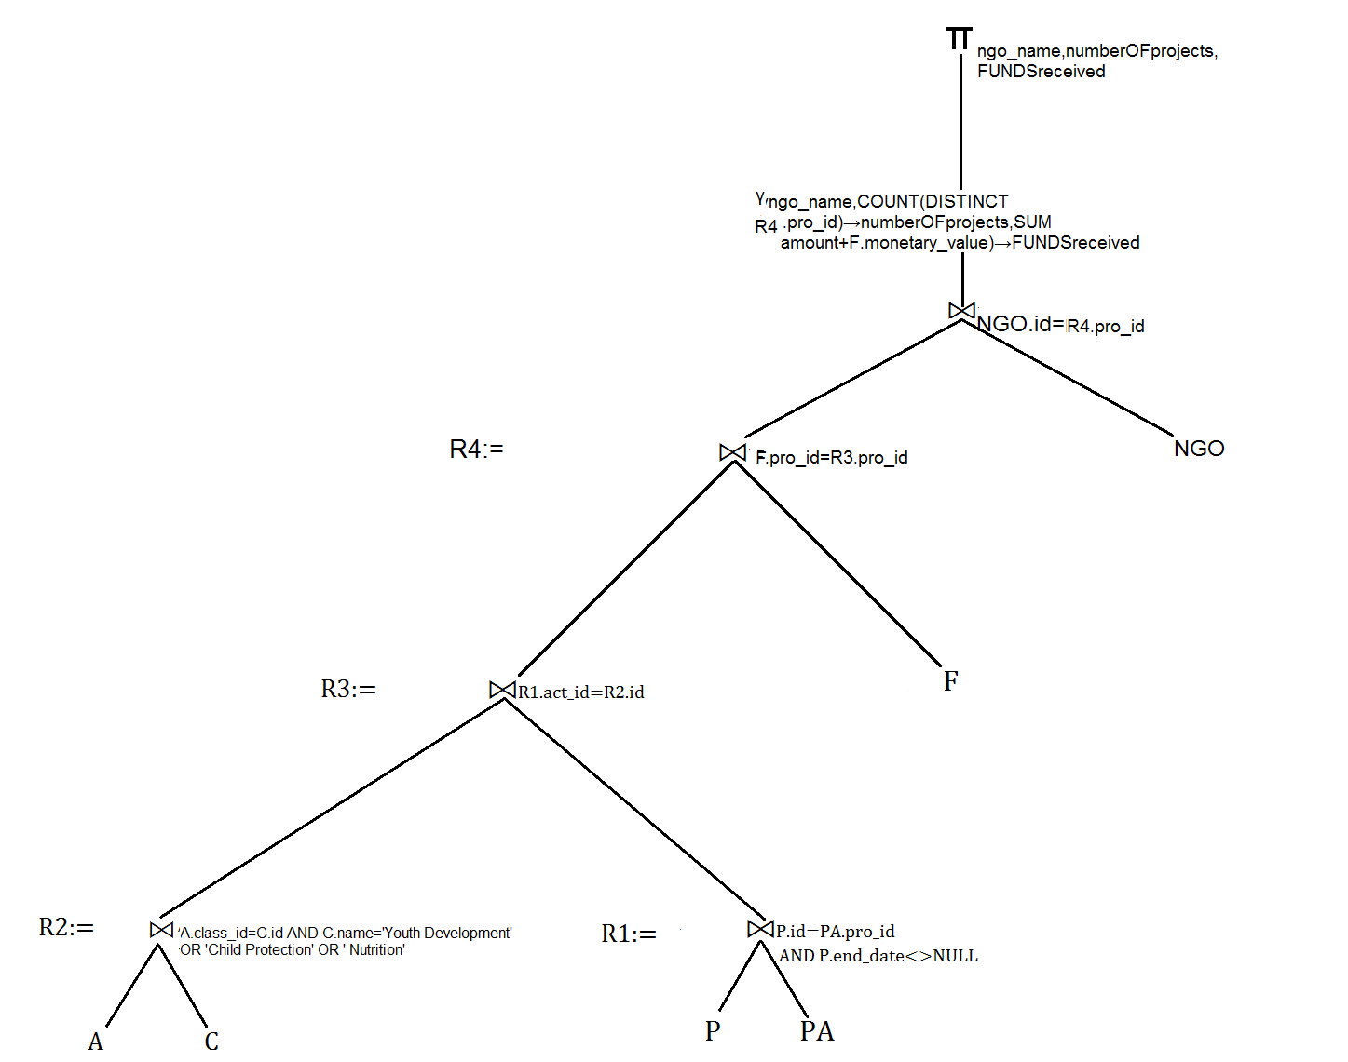

**Q3)** Identify the donors together with the total number of projects funded and amount

of funds targeting the groups of activities in [1] and [2].

**SQL Code with sample output:**

**SELECT**

d.donor_name as donor_name,COUNT(distinct f.pro_id) as no_of_projects_funded,format(sum(f.amount+f.monetary_value), 2) as amount_of_funds

**FROM**

donor d,

funds f,

project p,

project_activity pa,

activities a,

class c

**WHERE**

d.id = f.donor_id

and f.pro_id = p.id

and p.id = pa.pro_id

and pa.act_id = a.id

and a.class_id = c.id

and c.name in **('HEALTH','EDUCATION','GENDER','YOUTH DEVELOPMENT','CHILD PROTECTION','NUTRITION')**

**GROUP BY** donor_name

order by no_of_projects_funded desc;

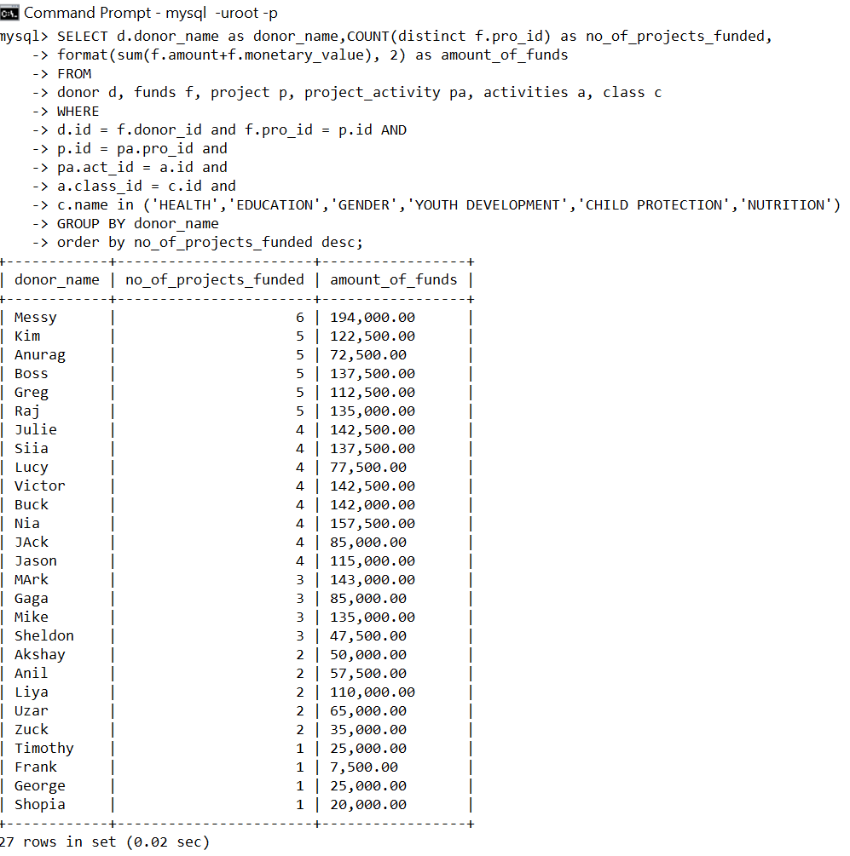

**RA Expression:**

**π**dname,numberOFprojects,FUNDSreceived

{

**γ**D.donor_name → dname,count(distinct R4.pro_id) → numberOFprojects, SUM(F.amount+F.monetary_value) → FUNDSreceived

{

**σ**D.id=R4.donor_id

[D **⨝**

[**σ**F.pro_id=R3.pro_id

(**ρ**(R4,F **⨝** (**σ**R1.act_id=R2.id((**σ**P.id=PA.pro_id AND P.end_date<>NULL(**ρ**(R1,(P **⨝** PA)))) **⨝** (**σ**A.class_id=C.id AND C.name='Health' OR 'Education' OR 'Gender' OR 'Youth Development' OR 'Child Protection' OR 'Nutrition'(**ρ**(R2,(A **⨝** C)))))))

]

]

}

}

**RA Expression Trees:**

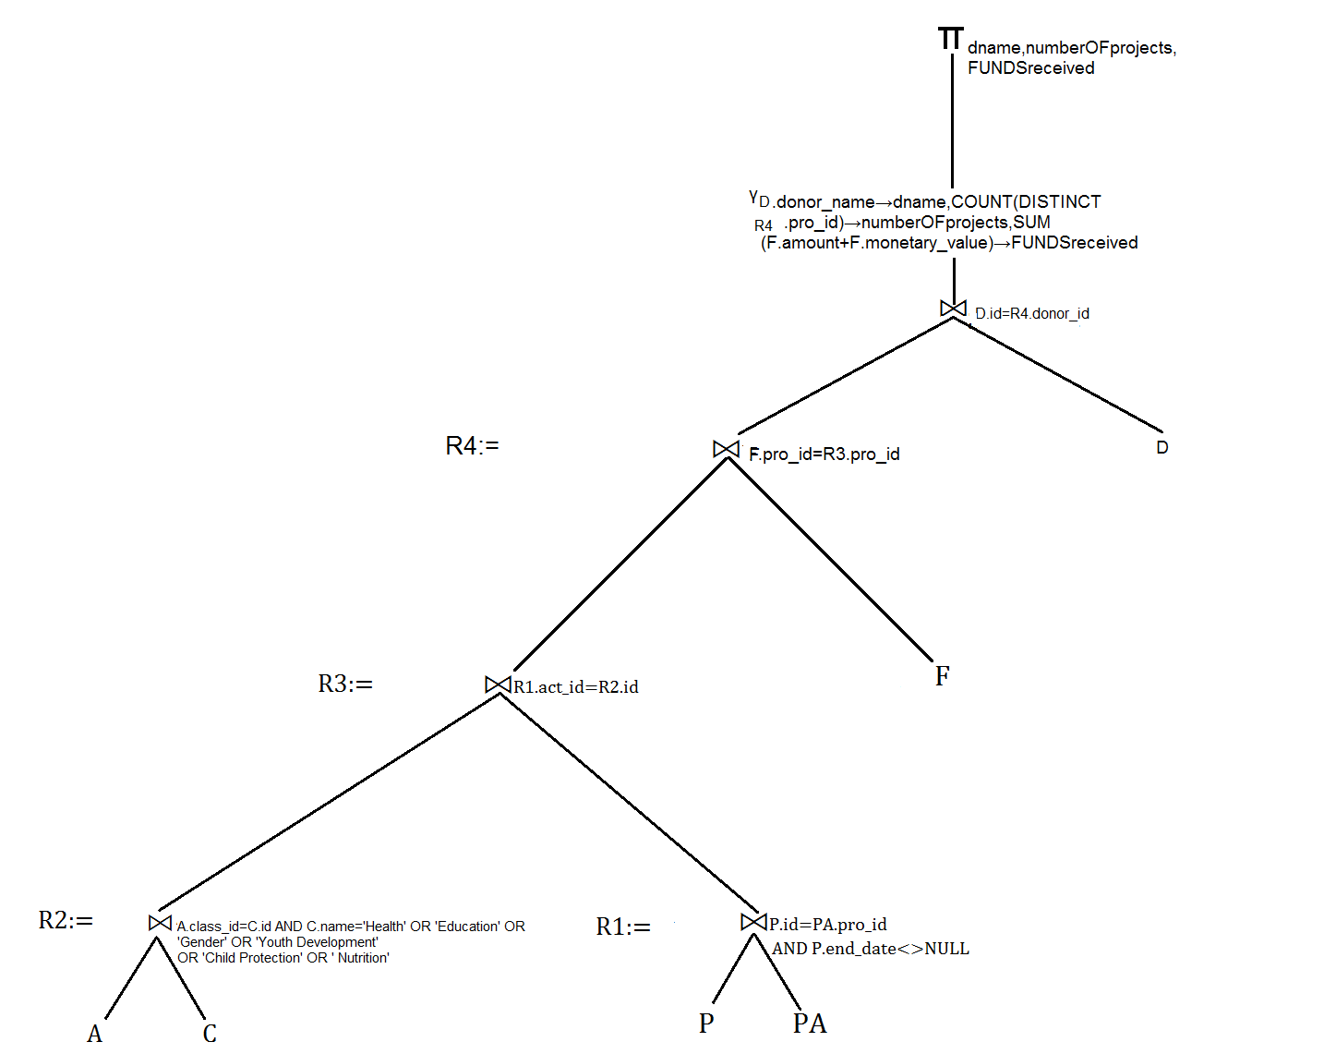

**Q4)** Repeat the queries in [1] and [2] to identify NGOs actively working in rural areas and slums together with the number of projects and total amount of funds received by each NGO.

**SQL Code with sample output:**

**SELECT**

n.ngo_name as ngo_name,count(distinct p.id) as no_of_projects,format(sum(f.amount+f.monetary_value), 2) as funds_received

**FROM**

ngo n,

funds f,

project p,

project_activity pa,

activities a,

class c

**WHERE**

n.id = f.ngo_id

and f.pro_id = p.id

and p.id = pa.pro_id

and pa.act_id = a.id

and a.class_id = c.id

and p.end_date is null

and c.name in ('HEALTH','EDUCATION','GENDER','YOUTH DEVELOPMENT','CHILD PROTECTION','NUTRITION')

and p.id in

(

SELECT DISTINCT ps.pro_id FROM project_scope ps,scope s WHERE ps.sco_id = s.id AND s.name IN (**'Rural' , 'Slum'**)

)

**group by** ngo_name

order by no_of_projects desc;

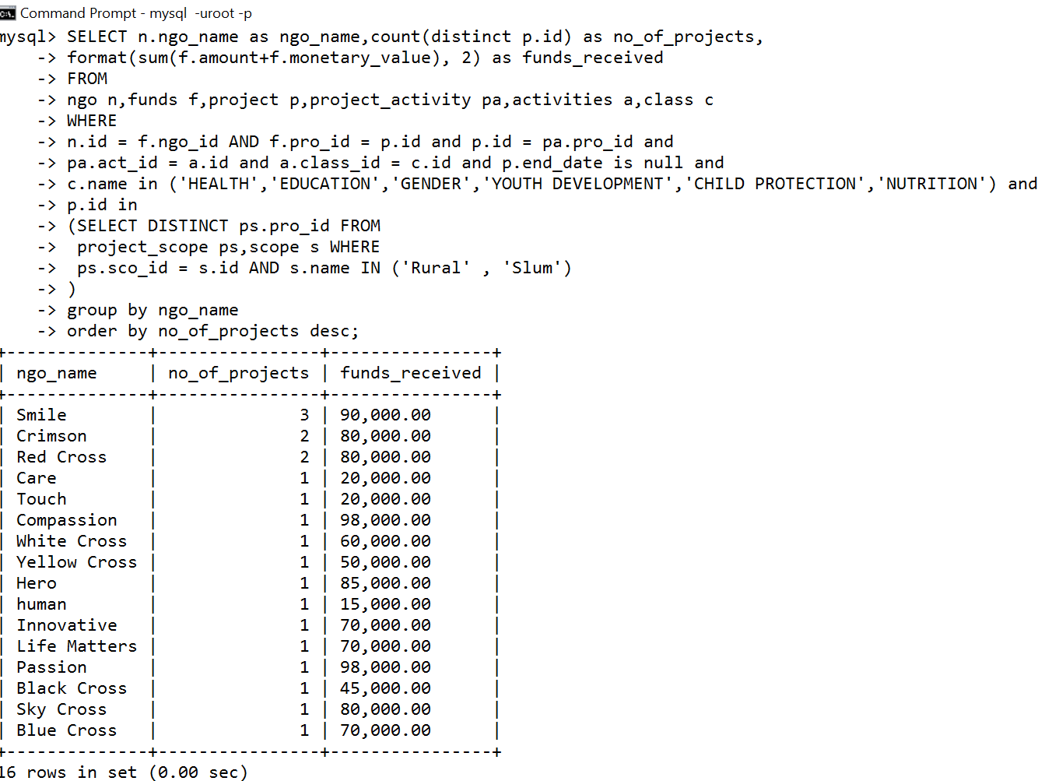

**RA Expression:**

**π**ngo_name,numberOFprojectsFUNDSreceived

{

**γ**ngo_name,count(distinct R5.pro_id) → numberOFprojects,SUM(F.amount+F.monetary_value) → FUNDSreceived

[

**σ**NGO.id=F.ngo_id

[

NGO **⨝**

[

**σ**F.pro_id=R4.pro_id

[

(**ρ**(R5,F **⨝** (**σ**P.id=PA.act_id(**σ**P.id=PS.pro_id AND P.end_date<>NULL(**ρ**(R3,P **⨝** (**σ**DISTINCT PS.pro_id(**σ**PS.sco_id=S.id AND S.name='RURAL' OR 'SLUM'(PS **⨝** S))))) **⨝** (**σ**PA.act_id=R2.act_id(**ρ**(R4,PA **⨝** (**σ**A.class_id=C.id AND C.name='Health' OR 'Education' OR 'Gender' OR 'Youth Development' OR 'Child Protection' OR 'Nutrition'(**ρ**(R2,(A **⨝** C)))))))))

]

]

]

]

}

**RA Expression Trees:**

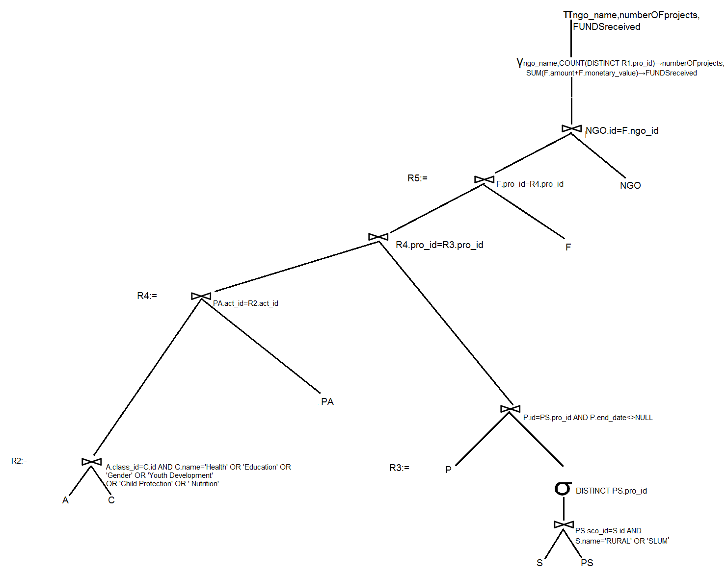

**Q5)** Identify the donors together with the total number of projects funded and amount

of funds targeting rural areas and slums.

**SQL Code with sample output:**

**SELECT**

d.donor_name as donar_name,count(distinct p.id) as projects_funded,format(sum(f.amount+f.monetary_value), 2) as total_funds_amount

**FROM**

donor d,

funds f,

project p

**WHERE**

d.id = f.donor_id

and f.pro_id = p.id

and p.id in

(

SELECT DISTINCT ps.pro_id FROM project_scope ps,scope s WHERE ps.sco_id = s.id AND s.name IN (**'Rural' , 'Slum'**)

)

**group by** d.donor_name

order by projects_funded desc;

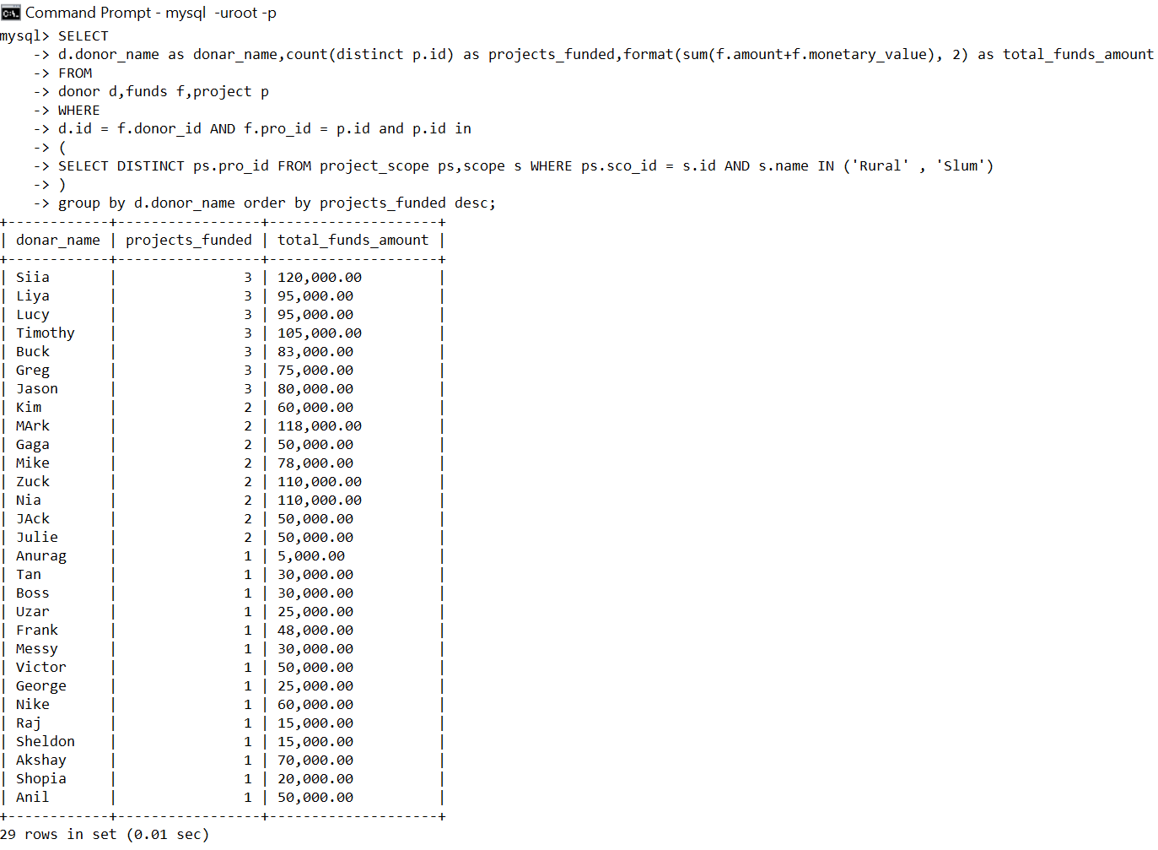

**RA Expression:**

**Π**donor_name, numberOFprojects, fundsReceived

{

**γ**donor_name, count(distinct R1.pro_id) → numberOFprojects, SUM(F.amount+F.monetary_value) → fundsReceived

[**σ**D.id=F.donor_id

[D **⨝**

(**σ**F.pro_id=.pro_id(F **⨝**

(**σ**P.id=PS.pro_id(**ρ**(R1,P **⨝** (**σ**PS.sco_id=S.id AND S.name='RURAL' OR

'SLUM'(PS **⨝** S)))))

)

)

]

]

}

**RA Expression Trees:**

